**7. Laboratory Exercise**

A. Program

i. Design UI for mobile app using the following widgets.

MaterialApp, Scaffold, AppBar, Text, Center, FloatingActionButton, TextStyle.

import 'package:flutter/material.dart';

void main() {

runApp(

const MaterialApp(

title: 'Flutter Tutorial',

home: TutorialHome(),

),

);

}

class TutorialHome extends StatelessWidget {

const TutorialHome({super.key});

@override

Widget build(BuildContext context) {

return Scaffold(

// Set the background color to baby pink

backgroundColor: Color(0xFFFBB0B0), // Light pink color

appBar: AppBar(

leading: const IconButton(

icon: Icon(Icons.*menu*),

tooltip: 'Navigation menu',

onPressed: null,

),

title: const Text('MAP EXPERIMENT-2'),

actions: const [

IconButton(

icon: Icon(Icons.*search*),

tooltip: 'Search',

onPressed: null,

),

],

),

body: const Center(

child: Text(

'Welcome to MAP Lab', // Add body text

style: TextStyle(

fontSize: 24, // Set font size

fontWeight: FontWeight.*bold*, // Make it bold

color: Colors.*black*, // Text color

),

),

),

floatingActionButton: const FloatingActionButton(

tooltip: 'Add',

onPressed: null,

child: Icon(Icons.*add*),

),

);

}

}

Output:

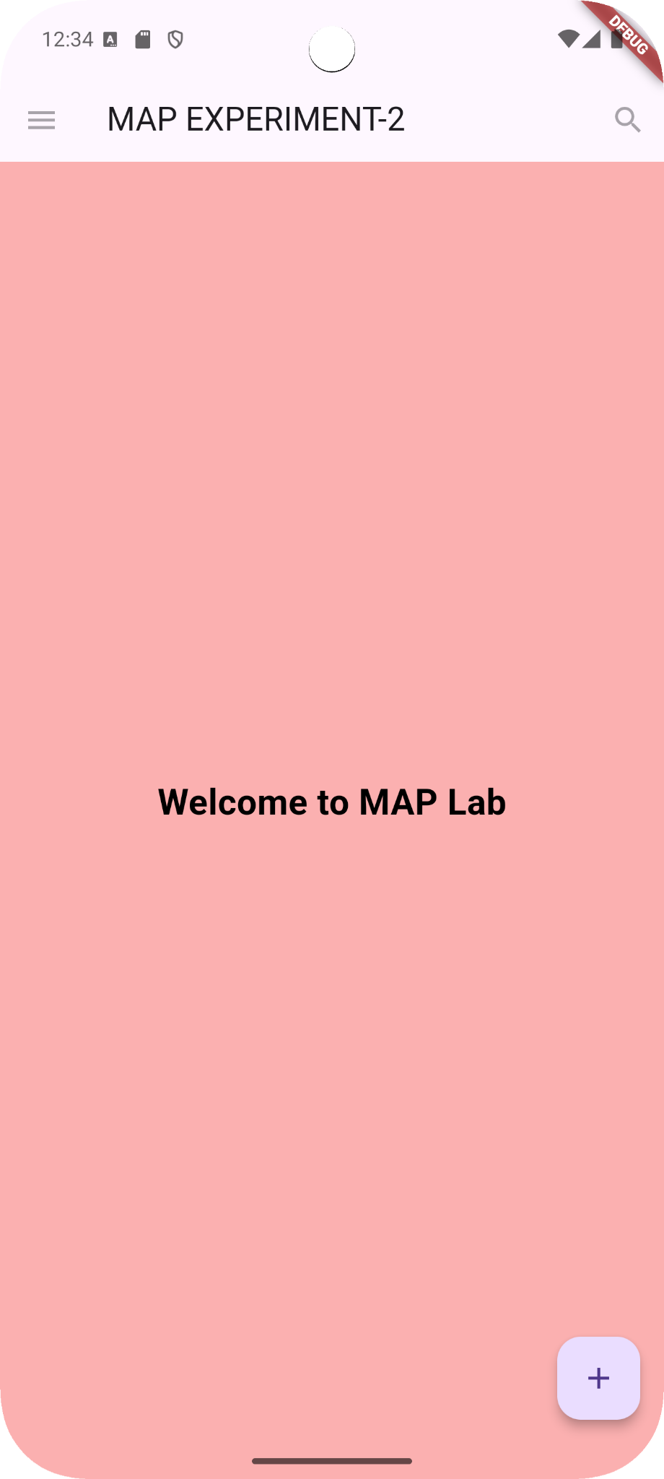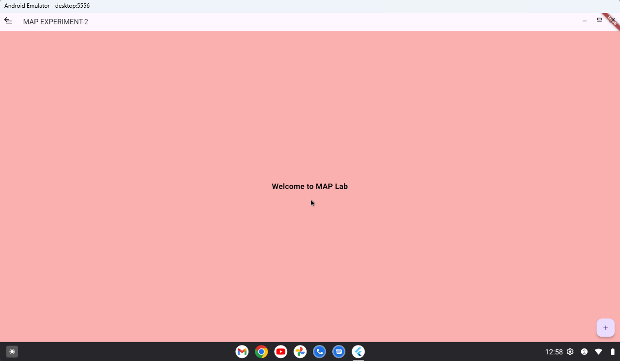

**8. Post-Experiments Exercise**

A. Questions:

1. Modify the app UI to include two more widgets and show the output.

| **CODE**:  import 'package:flutter/material.dart';  void main() => runApp(MaterialApp(  home: Scaffold(  appBar: AppBar(  title: Text('My First App'),  centerTitle: true,  ),  body: Center(  child: Column(  mainAxisAlignment: MainAxisAlignment.center,  children: <Widget>[  Text('Flutter App'),  SizedBox(height: 20), // Adds some space between the widgets  Text('This is an additional text widget.'),  SizedBox(height: 20), // Adds some space between the widgets  ElevatedButton(  onPressed: () {  // Action to perform when the button is pressed  print('Button Pressed!');  },  child: Text('Click Me'),  ),  ],  ),  ),  floatingActionButton: FloatingActionButton(  onPressed: () {  // Action to perform when the FAB is pressed  print('Floating Action Button Pressed!');  },  child: Text("Click me"),  ),  ),  )); | **OUTPUT**: |
| --- | --- |